929

1972
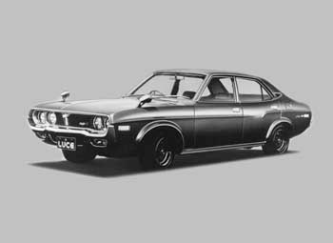
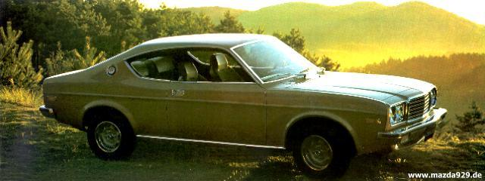
1976 Coupé
Length: | 4405mm | Motor: | Type: 4C (1800)
Width: | 1665mm
Hight: | 1380mm
Weight: | 1095kg
Displacemnt: | 1769ccm
Power: | 83PS @ 5000rpm
Torque: | 138Nm @ 2900rpm
Economy: | 10L/100km
Fuel Tank: | 62L
Top Speed: | 160 km/h
Turning Circle: | 11m | :

1978

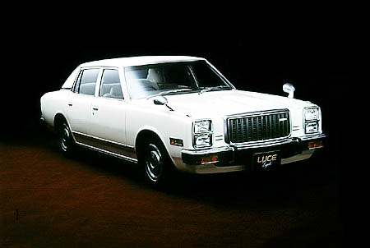

Dimensions | (L/W/H) | 4625X1890X1410
Dimensions | Wheel Base (mm) | 2610
Dimensions | Track | 1430 / 1400
Dimensions | Curb weight (Kg) | 1230
Dimensions | Seating Capacity | 5
Engine | F/MA 2,0 SOCH 90ps@4000rpm 165nm@2500rpm
Original Price |  | ???
Top Speed (km/h) |  | ???
Transmision |  | 3A / 5M
Brakes |  | Disk / Drum

1981

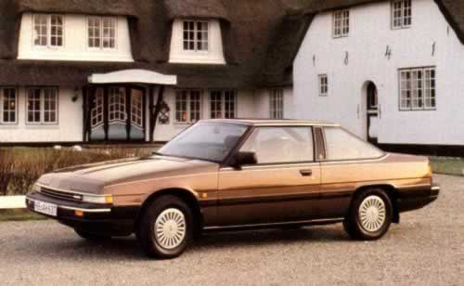
Power: 101PS @ 5600rpm (2.0) and 120PS @ 5300rpm (2.0i) - 1983 ( 92PS @ 5000rpm )
Top Speed: 180km/h ( 2.0 ) and 192km/h ( 2.0i )
Fuel Tank: 60L
Coupe ( 4690X1690X1410 ) ~ 1185kg
Sedan ( 4690X1690X1360 )
2 door 1175kg/1165kg (2.0i & 2.0 )
1.8L SOHC
2.0L SOHC
2.2L SOHC

1986
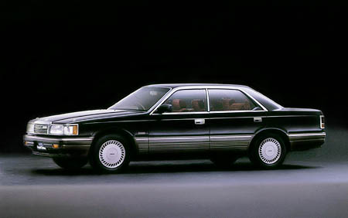
3 door ( 4690X1695X1395 ) 1450kg
2.0L V-6 SOHC 82ps @ 5000 / 15.2kg-m @ 2500
2.0L V-6 SOHC 110ps @ 5500 / 17.1kg-m @ 4000
2.0L V-6 SOHC 145ps @ 5000 / 23.5kg-m @ 2500
3.0L V-6 SOHC 160ps @ 5500 / 24.0kg-m @ 4000
3.0L V-6 SOHC 200ps @ 6500 / 25.0kg-m @ 3500
There was also a 13B and a 13B Turbo version avalable

1991

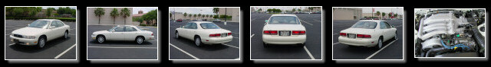
THIS IS A NORTH AMERICAN MAZDA 929 ( SERENIA )

This car was introduced in 1991 and it was a redesign of the older 929. The car was known as SENTIA in Japan and it was also sold as the Eunos MS-9. In North America the car was known as the SERENIA. The American market only got the 3.0L 200HP motor, while the rest of the world got smaller motors besides the big 3.0L
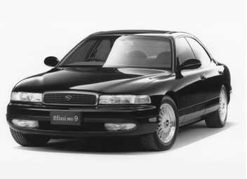
This is the Mazda 929 that was sold as a Sentia at Mazda dealers and MS-9 at Enfini dealers
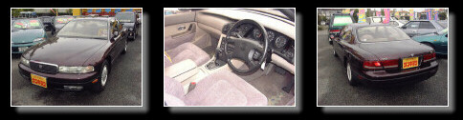
MS-9

Dimensions | (L/W/H) | 4925/1795/1380
Dimensions | Wheel Base (mm) | 2850
Dimensions | Curb weight (Kg) | 1640
Dimensions | Seating Capacity | 5
Original Price | 4140000
Engine | J5-ZE V-6 2.5L DOHC 160ps @ 6000 / 21.5kg-m @ 3500  JE-ZE V-6 3.0L DOHC 200ps @ 6000 / 27.7kg-m @ 3500 ( 90° Block )

SENTIA

Dimensions | (L/W/H) | 4925/1795/1380
Dimensions | Wheel Base (mm) | 2850
Dimensions | Curb weight (Kg) | 1640
Dimensions | Seating Capacity | 5
Original Price | 4130000
Engine | G6 2.6L DOHC 120ps @ 4500 / 20.6kg-m @ 3500 ( 4WD )

1995

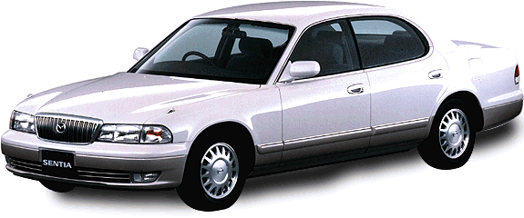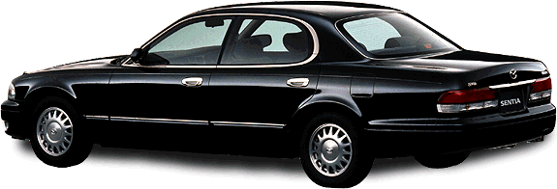
Dimensions | (L/W/H) | 4895/1795/1420
Dimensions | Wheel Base (mm) | 2850
Dimensions | Curb weight (Kg) | 1620kg ( DOHC ) 1530 ( SOHC )
Dimensions | Seating Capacity | 5
Original Price | 4250000
Engine | JE-ZE 3.0L DOHC 205ps @ 6000 / 27.7kg-m @ 3500 ( 2WS, 4WS)  JE-E 3.0L SOHC 160ps @ 5500 / 25.0kg-m @ 2500 ( 2WS, 4WS)

