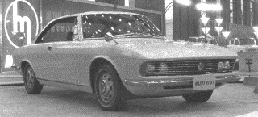
RX-87. The concept car that led to the Luce
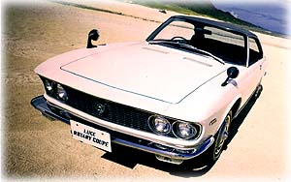Playing on the Mazda "God of Light" theme, the new model was dubbed the Luce. Fortunately the handsome, decidedly Italian lines of the car were essentially undisturbed. Mazda even avoided the current Japanese compulsion to overdecorate, using only modest badging and simple wheel covers. The grille area, with its quad headlights, is perhaps the best styling feature, reminiscent of certain Fiat 124 models, a favorable comparison.
The first vehicle to mount the Aerodynamic wiper blade system was a Mazda Luce produced by Tea Industries in Japan. In addition to the new design the wiper received a new finish as well: the shiny stainless steel levers were given a matte finish to reduce glare.

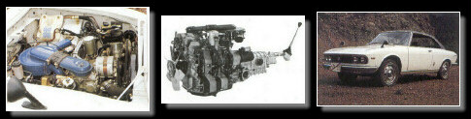
The Luce engine bay compartment taken by a 13A |  | 13A 3847 / 0823 two rotor 655cc chambers ( 1970-1972 ) |  | The sexy Luce Rotary Coupe

'69 MAZDA LUCE ( FWD )
ENGINES | CHASSIS NUMBER ( 13A )
Rotary | 126ps@6000 - 17.5kg-m@3500rpm
Displacement x rotors | 655cc x 2
L - W - H | 4585 - 1635 - 1385
Wheel base | 2580
Track F/R | 1330/1325
Top Speed | 190
Economy | 5.6L
Turning Radius | 4.9m
0-400m | 16.9s
Fuel Tank | 40L
Weight | 1255
Tires | 165HR15
Passengers | 5
Price: | DX 1,45,000  SDX 1,750,000

